Financial Risk Analysis
PROJECT ABSTRACT:
- Understand customer financial data.
- Perform data cleaning and preprocessing.
- Handle missing values, duplicates, and outliers.
- Analyze important financial features.
- Prepare the dataset for machine learning to predict financial risk.

DATASET OVERVIEW:
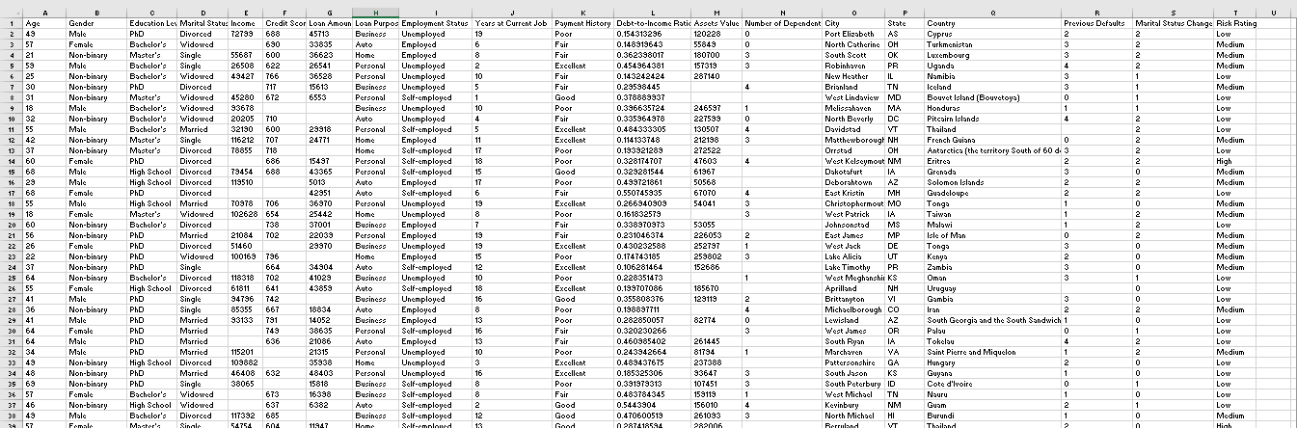

Rows: 16,500
Columns: 20
Feature | Description
Age | Age of the customer in years.
Gender | Gender of the customer (Male/Female).
Education Level | Highest education qualification of the customer.
Marital Status | Customer's marital status (Single, Married, etc.).
Income | Annual income of the customer.
Credit Score | Numerical score representing the customer's creditworthiness.
Loan Amount | Total amount of loan requested or sanctioned.
Loan Purpose | Reason for taking the loan (Home, Car, Education, Personal, etc.).
Employment Status | Current employment status of the customer (Employed, Self-employed, Unemployed, etc.).
Years at Current Job | Number of years the customer has been working at the current job.
Payment History | Record of previous loan or credit repayments (Good, Average, Poor).
Debt-to-Income Ratio | Ratio of total debt to annual income, indicating repayment capacity.
Assets Value | Total estimated value of the customer's assets.
Number of Dependents | Number of family members financially dependent on the customer.
City | Customer's city of residence.
State | Customer's state of residence.
Country | Customer's country of residence.
Previous Defaults | Number of previous loan payment defaults by the customer.
Marital Status Change | Indicates whether the customer's marital status has changed.
Risk Rating | Target variable indicating the customer's financial risk level (e.g., Low, Medium, High).

DATA CLEANING:
Removed Duplicates:
- df.drop_duplicates()

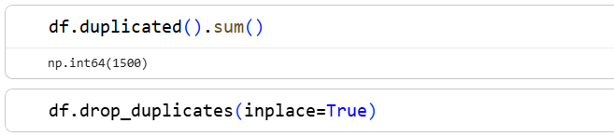

Handled Missing Values:
- Age → Filled using median value
- Gender → Filled with mode (most frequent value)
- Education Level → Filled using mode
- Marital Status → Filled using mode
- Income → Filled using median value
- Credit Score → Filled using median value
- Loan Amount → Filled using median value
- Loan Purpose → Filled using mode
- Employment Status → Filled using mode
- Years at Current Job → Filled using median value
- Payment History → Filled using mode
- Debt-to-Income Ratio → Filled using median value
- Assets Value → Filled using median value
- Number of Dependents → Filled using median value
- City → Filled using mode
- State → Filled using mode
- Country → Filled using mode
- Previous Defaults → Filled using mode
- Marital Status Change → Filled using mode
- Risk Rating → Filled using mode
